Matthew Austin

Cryptology

Anwar

November 2018

Cryptographic Protocols

* 1.
  + G. I captured 19 client packets and 17 server packets. It has captured majority of my packets and with tcp stream, I am able to see the full interaction/conversion, including all of the information that I input.
  + 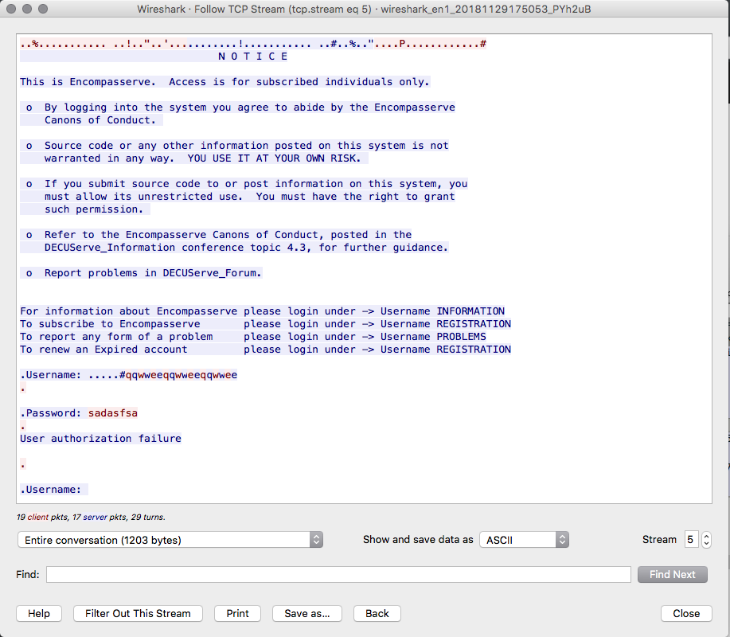
  + 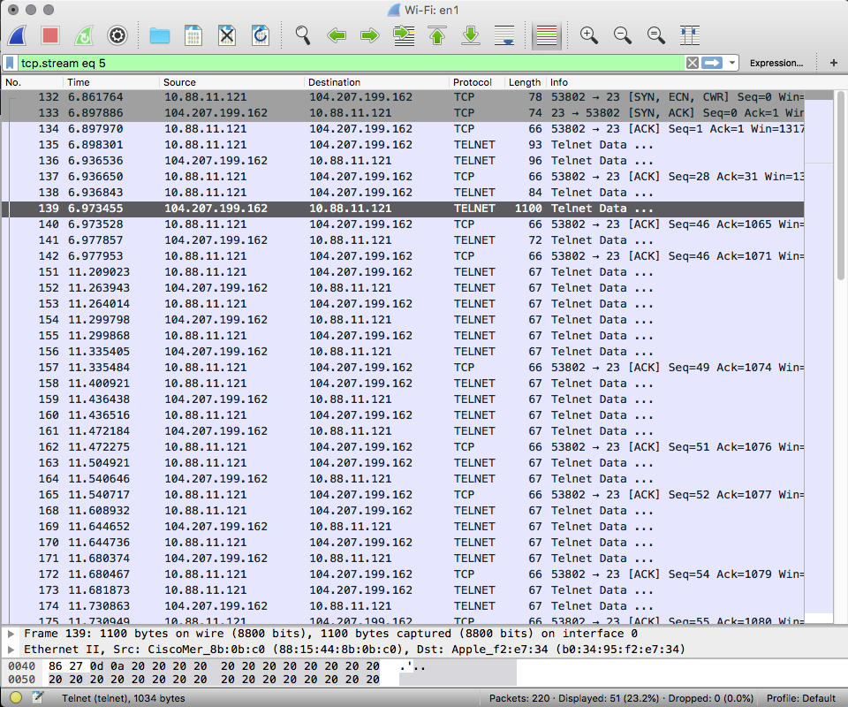
* I
  + Red is the data sent by the client and blue is the data sent by the server. The initial red and blue messages are is the handshake. Once the handshake is completed the data that is sent between the client and server is encrypted.
  + 
   